# **Visualización de Datos – Javier Gómez**

## **PEC 2 – Enlaces**

[**Pyramid Chart**](https://public.flourish.studio/visualisation/9451149/)

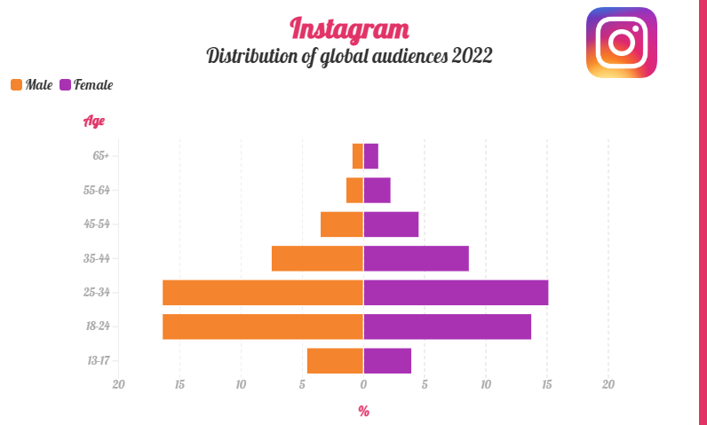

[**Slope Chart**](https://public.flourish.studio/visualisation/9441674/)

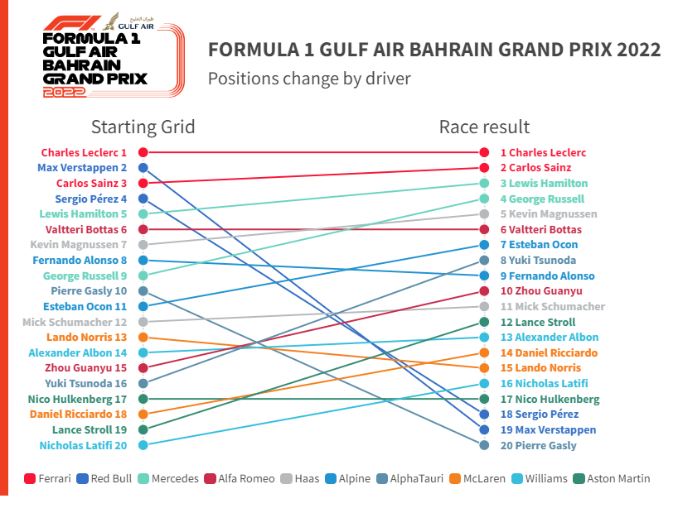

[**OHLC Chart**](https://github.com/javi22gd/VD)

